ROSCOMMON GOLF CLUB

Mote Park,Roscommon

Please

Affix

Passport

Size

Telephone 0906626382

Photograph

here

www.roscommongolfclub.ie

email roscommongolfclub@gmail.com

APPLICATION FOR MEMBERSHIP 2025

(To be completed in Block Letters)

**SURNAME:.......................................................................... FIRST NAME: ........................................................................................**

**FULL POSTAL ADDRESS : .................................................................................................................................................................**

**.**

**..................................................................................................................................................................................................................**

**TELEPHONES: HOME: ........................................ OFFICE:......................................... MOBILE: .................................................**

**DATE OF BIRTH: ................................................................... SEX : MALE / FEMALE**

**EMAIL ADDRESS :................................................................................................................................................................................**

**Club communication will be by email and or phone so please provide both. By providing your email address you agree to**

**receive communication by email from the club.**

**CIRCLE CATEGORY APPLICABLE:**

**SENIOR ( 80 yrs + ) UNDER 28**

**PAVILLION UNIVERSITY**

**BEGINNER**

**OVERSEAS**

**DISTANCE > 75km**

**LAPSED**

**FULL**

**COUNTRY**

**WERE YOU PREVIOUSLY A MEMBER OF ROSCOMMON GOLF CLUB ? If YES PLEASE**

**PROVIDE YEAR MEMBERSHIP CEASED. YEAR: ................................**

**PRESENT CLUB (**if any): **.......................................... Golf Ireland No:................................... HANDICAP NDEX ......................**

**I wish to apply for membership of Roscommon Golf Club. I hereby agree to observe all the rules and regulations and bye**

**laws of the club and hereby undertake and agree to accept the decision of the committee of the club as final and binding on**

**me in all respects. I agree to abide by the Irish Anti Doping rules.**

**In the event that my membership application is successful, I shall give first preference to represent Roscommon Golf Club,**

**in the event of my being selected by the club and I being available to play for Club teams in National and Local**

**competitions.**

**APPLICANTS SIGNATURE: ................................................................................................. DATE: ..............................................**

**Proposer’s signature....................................................................... Name in Block Capitals: ............................................................**

**Seconder’s signature ...................................................................... Name in Block Capitals:**

**.**

**.............................................................**

Note: The Proposer and Seconder of successful new applicants are responsible for thier introduction to the club, and it is also their

responsibility to ensure that each new member has adequate knowledge of the etiquette of golf.

**Required Documentation:** All membership applications must be accompanied by proof of primary residence, handicap certificate

if moving club. Application must be accompanied with payment..

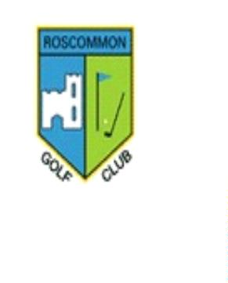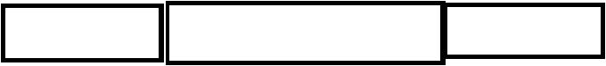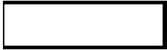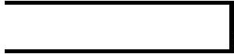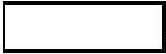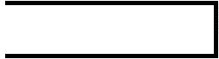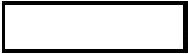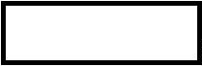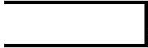

**MEMBERSHIP**

**CATEGORY**

**SUBSCRIPTION**

**POLL TAX**

**BAR LEVY**

**TOTAL**

**FULL**

**€675.00**

**€350.00**

**€30.00**

**€30.00**

**€50**

**€50**

**€50**

**€755**

**€430**

**SENIOR**

**BEGINNER Yr 1**

**€350.00**

**€350.00**

**€30.00**

**€30.00**

**€430**

**€430**

**Yr 2**

**DISTANCE**

**COUNTRY**

**€250.00**

**€350.00**

**€30.00**

**€50**

**€50**

**€330**

**€400**

**Home Club**

**UNIVERSITY**

**OVERSEAS**

**€200.00**

**€250.00**

**€30.00**

**€30.00**

**€50**

**€50**

**€280**

**€330**

**PAVILLION**

**€160.00**

**N/A**

**€50**

**€210**

**LAPSED**

**Under 28**

**€400.00**

**€475.00**

**€30.00**

**€30.00**

**€50**

**€50**

**€480**

**€555**

1

2

.

.

FULL MEMBERSHIP applies to members as per Clause 11.1.1 of Club Constitution.

SENIOR MEMBERSHIP applies to members who are 80 years of age on the 1st day of the Subscription

year and who have been a club member for more than 10 years.

3

4

5

6

.

.

.

.

BEGINNER MEMBERSHIP applies to a person who has never had a golf handicap and has never been

a registered member of any Golf Club. Year 2 fee may increase at AGM.

DISTANCE MEMBERSHIP applies to a person permanently living 75 km or more from Roscommon

Golf Club. Utility Bill required.

COUNTRY MEMBERSHIP applies to a person who is already a full member of another affiliated golf

club whose permanent residence is 10 miles / 17km or more distant from Roscommon Golf Club.

UNIVERSITY MEMBERSHIP applies to a member who is atudying for an undergraduate degree at an

approved Third Level Institution. Letter from college stating you are attending on a full time basis is

required.

7

8

.

.

OVERSEAS MEMBERSHIP applies to a person who is resident outside Ireland.

PAVILLION MEMBERSHIP applies to members who wish to enjoy the facilities of the clubhouse.

Such persons shall not be entitled to use the course without payment of the appropriate fee.

9

1

.

LAPSED MEMBERSHIP applies to a person who has allowed their membership of Roscommon Golf

Club to lapse for 4 years or more.

0. UNDER 28 YEARS applies to a person who is under 28 years iof age on the 1st day of Subscription

years.. Proof of age must accompany the membership application.

**For Club Use Only**

Signed:

Date Approved :

Club Secretary

Please return application and payment to Honorary Registrar, Roscommon Golf Club, Mote Pk, Roscommon

